Benton County Juvenile Court
5606 West Canal Place ♦ Kennewick, WA 99336-1388
(509) 783-2151  ♦ Fax (509) 736-2728
Benton County GAL Program

Dear Volunteer:

Please fill out the attached documents completely. (Print each page separately)

Application
Include 4 references with complete email and mailing address (Please write clearly and ensure accuracy and please do not include relatives)
Sign and date application
Complete GAL Program Attachment, pages 4 & 5

Volunteer Oath of Office
Print your name, then sign and date form.

Information and Systems Agreement
Signature required

RCW 13.40.570
Read and initial RCW 13.40.570

Volunteer Background Check Authorization and Release
Please provide information requested on both pages
Signature required
Include a copy of your driver’s license

Waiver of Confidentiality GAL Program
Signature and date required (Please print name also)

Volunteer Background Information Sheet
Fill out all that applies to you
Signature required
Copy of Noncriminal Justice Applicant’s Privacy Rights provided

DCYF (Children’s Administration) Authorization for Records Check
Fill out section C (Yellow highlighted section: name, DOB, former names, address, etc.)
Signature Page (sign & date)

Noncriminal Justice Applicants Privacy Rights
Initial and date

Please print the packet one-sided (with each page separate) and return to the GAL Office at the above address.


Benton County
Juvenile Court

Gordon Thomasson
Administrator

5600 W Canal Place
Kennewick, WA 99336
PHONE (509) 783-2151

Hon. Jacqueline Stam
Presiding Juvenile Court Judge

VOLUNTEER/INTERN APPLICATION

LAST NAME: FIRST NAME: MIDDLE:

HOME ADDRESS:
(Street) (City) (Zip)

BIRTH DATE: GENDER: SSN:

HOME PHONE: CELL PHONE: ___________ ______ EMAIL: _ _____________

IN CASE OF EMERGENCY, NOTIFY: PHONE

RELATIONSHIP TO YOU:

EMPLOYER: WORK PHONE:

WORK ADDRESS: OCCUPATION (Street) (City) (Zip)

CIRCLE THE HIGHEST GRADE COMPLETED: 8 9 10 11 12 13 14 15 16 DEGREE:

AREA OF STUDY: CURRENTLY IN SCHOOL: YES NO WHERE?

DO YOU OWN AN OPERABLE AUTOMOBILE? YES NO IS THIS AUTOMOBILE INSURED? YES NO

NAME OF INSURANCE COMPANY: AGENT:

WHAT LANGUAGE (S) DO YOU: SPEAK READ WRITE

ORGANIZATION YOU REPRESENT:

ORGANIZATION’S ADDRESS: PHONE:

DEPARTMENT WITHIN JUVENILE COURT YOU WISH TO WORK WITH: (Guardian ad Litem)

WERE YOU REFERRED TO THIS AGENCY BY AN EMPLOYEE OF THE JUVENILE COURT? YES NO

IF YES, WHO REFERRED YOU?

WHY DO YOU WANT TO VOLUNTEER WITH THE JUVENILE COURT AND WHAT IS THE LENGTH OF COMMITMENT YOU COULD GIVE TO THIS AGENCY?

LIST ANY VOLUNTEER EXPERIENCE:

HAVE YOU HAD ANY EXPERIENCE WITH CHILD ABUSE?

PRESENT HEALTH: ANY HEALTH PROBLEMS EXPLAIN)

PERSONAL INTERESTS, HOBBIES, OR SKILLS:

PLEASE LIST FOUR (4) REFERENCES: (INCLUDE AN EMPLOYER OR IMMEDIATE SUPERVISOR, IF APPLICABLE, AND AT LEAST TWO (2) PEOPLE WHO HAVE KNOWN YOU FOR TWO YEARS OR LONGER)

NAME | RELATIONSHIP  (Non-Relative) | CONTACT INFORMATION  Please write clearly and ensure accuracy. (Include City, State & Zip Code)
Email:

Address:
Email:

Address:
Email:

Address:
Email:

Address:

COMMENTS:

In my service as a volunteer, I agree that I am acting as an agent of the Juvenile Justice Center, and I will exercise due cause and act in good faith. I will respect and abide by the rights and responsibilities of professional staff noted on the reverse of this application.

I hereby declare that the above information is true and correct to the best of my knowledge.

SIGNATURE: DATE:

EQUAL OPPORTUNITY/AFFIRMATIVE ACTION POLICY: The Benton-Franklin Counties Juvenile Justice Center (BFJJC) does not discriminate in regard to race, color, religion, sex, nation origin, age, political affiliation, disability status or any other non-merit factor. BFJJC is also committed to an Affirmative Action Program.

Volunteer Application
(GAL Program Attachment)

1. Why would you like to become a GAL volunteer?

2. As a volunteer, what would you like to accomplish for yourself?

3. Have you had any personal experience involving
Child Welfare System Court System Foster care Child servicing agencies?
If yes, please explain:

4. List any health problems or handicaps you have which should be taken into account:

5. Have you ever been a victim of abuse, including domestic violence? Yes No
If yes, please describe what steps you have taken to deal with the abuse issue(s):

6. Have you or a member of your family been investigated by Child Protective Services? Yes No
If yes, please explain whom it involved and to what extent:

7. Have you or a member of your family experienced an addiction to illegal substances (drugs or alcohol)?
Yes No If yes, please explain:

8. Have you or a member of your family been involved or referred to Juvenile Probation? Yes No
If yes, please explain:

9. Do you have a divorce/custody proceeding in Superior Court and have a GAL assigned on your case?
Yes No If yes, please explain:

NOTE: Please attach a statement on a separate sheet of paper regarding the circumstances for any “yes” answers to the following questions:
10. Have you been in the past or are you currently involved in any court proceedings? Yes No Where?

11. Are you currently on probation or parole? Yes No

12. Have you had your name placed on a registry of child or adult abuse in this or any other city, county or state?
Yes No

13. Have you ever been denied a license to care for children or adults? Yes No

14. Have you ever had a license to care for children or adults suspended or revoked? Yes No

Benton County
Juvenile Court

Gordon Thomasson
Administrator

5600 W Canal Place
Kennewick, WA 99336
PHONE (509) 783-2151

Hon. Jacqueline Stam
Presiding Juvenile Court Judge

JUVENILE COURT VOLUNTEER OATH OF OFFICE

I will conscientiously do my best to serve the court and the community as a representative of the Benton-Franklin Counties Juvenile Justice Center. I will provide services to the court as directed and authorized, and abide by the rules, regulations, policies and code of ethics of the court.

I will keep confidential any information, records, files, papers, and/or communications to which I gain access in the course of my duties. I will not disclose any information except to those who have recognized status in the matter or unless otherwise directed by the court.

As a court volunteer, I understand that I am a mandated reporter 24 hours a day. I will report all incidences of abuse or neglect pursuant to RCW 26.44.030, and will complete a written verification form as provided by the agency.

I certify that I have read and am knowledgeable of the requirements of RCW 13.40.570 (see attached – Sexual misconduct by state employees, contractors) and of the new crimes committed included in RCW 9a.44, Sexual Offense (see attached listing).

In the event that there is a change in my criminal history status during my volunteerism with the Benton-Franklin Juvenile Justice Center, I will notify my immediate supervisor or manager by the next business day.

Juvenile Court Volunteer

Juvenile Court Volunteer Signature Date

Attached: RCW 13.40.570 – Sexual misconduct by state employee, contractors
Chapter 9A.44 RCW Sex Offenses – List of RCW Sections

Benton County
Juvenile Court

Gordon Thomasson
Administrator

5600 W Canal Place
Kennewick, WA 99336
PHONE (509) 783-2151

Hon. Jacqueline Stam
Presiding Juvenile Court Judge

Information and Systems Agreement

As a court employee, I understand that I may have access to confidential, as well as public information and records in files and databases, to include but not limited to, court case files, Juvenile Tracking System (JTS), the Judicial Information System/Juvenile and Corrections System (JIS/JCS), Liberty, Odyssey, Inside Washington Courts and databases of other organizations, including but not limited to I-leads and Powerschool. By signing this statement, I affirm my understanding of my responsibilities to maintain confidentiality and agree to the following:

- I understand that I may access, read or handle confidential records to the extent required in, and for the purpose of, performing my assigned duties as an employee of the court.

- I agree to use all state and local systems I have access to for work duty purposes only. At no time will I use systems for personal use.

3. I agree not to divulge, publish, or otherwise make known to unauthorized persons or to the public any confidential information obtained during my employment with the Court. I understand that:
a. I may divulge confidential information to judicial officers and authorized court employees as necessary to perform my job duties.
b. I may divulge confidential information to others only if specifically authorized to do so by statute, court rule, judicial policy, or court order.
c. Maintaining confidentiality includes not discussing confidential information outside of the workplace, or outside of my official work duties, to include social media posts or comments.

- I agree to consult my supervisor on any questions I may have concerning whether information may be disclosed.

- I understand that using this information for non-work duty purposes or unauthorized release of confidential information may be grounds for disciplinary or legal action, to include termination of employment.

- I agree to notify my supervisor immediately should I become aware of a situation, which could result in a violation of this agreement, whether this be on my part or on the part of another person.

Signature |  | Date |  | Printed Name

WASHINGTON STATE LEGISLATURE


Chapter 9A.44 RCW

Sex Offenses

RCW Sections
9A.44.010 | Definitions.
9A.44.020 | Testimony -- Evidence -- Written motion -- Admissibility.
9A.44.030 | Defenses to prosecution under this chapter.
9A.44.040 | Rape in the first degree.
9A.44.045 | First degree rape -- Penalties.
9A.44.050 | Rape in the second degree.
9A.44.060 | Rape in the third degree.
9A.44.073 | Rape of a child in the first degree.
9A.44.076 | Rape of a child in the second degree.
9A.44.079 | Rape of a child in the third degree.
9A.44.083 | Child molestation in the first degree.
9A.44.086 | Child molestation in the second degree.
9A.44.089 | Child molestation in the third degree.
9A.44.093 | Sexual misconduct with a minor in the first degree.
9A.44.096 | Sexual misconduct with a minor in the second degree.
9A.44.100 | Indecent liberties.
9A.44.105 | Sexually violating human remains.
9A.44.115 | Voyeurism.
9A.44.120 | Admissibility of child's statement -- Conditions.
9A.44.130 | Registration of sex offenders and kidnapping offenders -- Procedures -- Definition -- Penalties.
9A.44.135 | Address verification.
9A.44.140 | Registration of sex offenders and kidnapping offenders -- End of duty to register -- Expiration of subsection.
9A.44.145 | Notification to offenders of changed requirements.
9A.44.150 | Testimony of child by closed-circuit television.
9A.44.160 | Custodial sexual misconduct in the first degree.
9A.44.170 | Custodial sexual misconduct in the second degree.
9A.44.180 | Custodial sexual misconduct -- Defense.
9A.44.900 | Decodifications and additions to this chapter.
9A.44.901 | Construction -- Sections decodified and added to this chapter.
9A.44.902 | Effective date -- 1979 ex.s. c 244.
9A.44.903 | Section captions -- 1988 c 145.

WASHINGTON STATE LEGISLATURE

RCW 13.40.570

Sexual misconduct by state employees, contractors. (Effective July 1, 2006.)

(1) When the secretary has reasonable cause to believe that sexual intercourse or sexual contact between an employee and an offender has occurred, notwithstanding any rule adopted under chapter 41.06 RCW the secretary shall immediately suspend the employee.
(2) The secretary shall immediately institute proceedings to terminate the employment of any person:
(a) Who is found by the department, based on a preponderance of the evidence, to have had sexual intercourse or sexual contact with the offender; or
(b) Upon a guilty plea or conviction for any crime specified in chapter 9A.44 RCW when the victim was an offender.
(3) When the secretary has reasonable cause to believe that sexual intercourse or sexual contact between the employee of a contractor and an offender has occurred, the secretary shall require the employee of a contractor to be immediately removed from any employment position which would permit the employee to have any access to any offender.
(4) The secretary shall disqualify for employment with a contractor in any position with access to an offender, any person:
(a) Who is found by the department, based on a preponderance of the evidence, to have had sexual intercourse or sexual contact with the offender; or
(b) Upon a guilty plea or conviction for any crime specified in chapter 9A.44 RCW when the victim was an offender.
(5) The secretary, when considering the renewal of a contract with a contractor who has taken action under subsection (3) or (4) of this section, shall require the contractor to demonstrate that there has been significant progress made in reducing the likelihood that any of its employees will have sexual intercourse or sexual contact with an offender. The secretary shall examine whether the contractor has taken steps to improve hiring, training, and monitoring practices and whether the employee remains with the contractor. The secretary shall not renew a contract unless he or she determines that significant progress has been made.
(6)(a) For the purposes of RCW 50.20.060, a person terminated under this section shall be considered discharged for misconduct.
(b)(i) The department may, within its discretion or upon request of any member of the public, release information to an individual or to the public regarding any person or contract terminated under this section.
(ii) An appointed or elected public official, public employee, or public agency as defined in RCW 4.24.470 is immune from civil liability for damages for any discretionary release of relevant and necessary information, unless it is shown that the official, employee, or agency acted with gross negligence or in bad faith. The immunity provided under this section applies to the release of relevant and necessary information to other public officials, public employees, or public agencies, and to the public.
(iii) Except as provided in chapter 42.56 RCW, or elsewhere, nothing in this section shall impose any liability upon a public official, public employee, or public agency for failing to release information authorized under this section. Nothing in this section implies that information regarding persons designated in subsection (2) of this section is confidential except as may otherwise be provided by law.
(7) The department shall adopt rules to implement this section. The rules shall reflect the legislative intent that this section prohibits individuals who are employed by the department or a contractor of the department from having sexual intercourse or sexual contact with offenders. The rules shall also reflect the legislative intent that when a person is employed by the department or a contractor of the department, and has sexual intercourse or sexual contact with an offender against the employed person's will, the termination provisions of this section shall not be invoked.
(8) As used in this section:
(a) "Contractor" includes all subcontractors of a contractor;
(b) "Offender" means a person under the jurisdiction or supervision of the department; and
Volunteer Initials

_______________
(c) "Sexual intercourse" and "sexual contact" have the meanings provided in RCW 9A.44.010.

Benton County
Juvenile Court

Gordon Thomasson
Administrator

5600 W Canal Place
Kennewick, WA 99336
PHONE (509) 783-2151

Hon. Jacqueline Stam
Presiding Juvenile Court Judge

VOLUNTEER BACKGROUND CHECK AUTHORIZATION AND RELEASE
PRINT LEGIBLY:
Last Name |  |  |  | First Name |  |  |  |  |  |  |  | Middle Name
All Other Previous Names Used |  |  |  |  |  |  | Date of Birth (MM/DD/YYYY)
Driver’s License Number/State |  |  |  |  |  |  | Social Security Number
States of Residence (Current and all former within last 10 years)
Acknowledgement
A background check is required of all Benton-Franklin Counties Juvenile Justice Center (BFJJC) volunteers assigned to work with youth or programs affiliated with BFJJC. Successful completion of the background check, as determined by BFJJC, is required prior to the first day of assignment. I understand that volunteer status with BFJJC is contingent upon the results of a background check. I understand that adverse findings during my background check may result in withdrawal of any offer of assignment with BFJJC, and/or termination of my assignment with BFJJC. I further understand that if I am found to have made any false or misleading statements in my application or background check materials, I may have my volunteer status terminated even after I have started an assignment, and may subject myself to criminal prosecution.

Authorization and Release
I hereby authorize BFJJC to conduct a background check in connection with my application for volunteer assignment with BFJJC. I understand that this background check may include, but is not limited to, a review of records on file with the Washington State Patrol, the FBI National Crime Information Computer (NCIC) and Interstate Identification Index (III), local law enforcement agencies, the Department of Licensing, courts of law, and other agencies, and also may, depending upon my assignment, involve fingerprinting. I understand that a more comprehensive background check is required for certain BFJJC volunteer positions and may include review of records relating to arrests and/or other contacts with law enforcement.

This release form authorizes yearly background/fingerprint checks as required by law on all GAL volunteers while on active cases, social security number verification every 4 years, and a National Sex Offender Registry background check.

I hereby authorize and request any person, government entity, law enforcement or criminal justice agency and/or other organization (public or private) to provide any information and/or records solicited by BFJJC in connection with my volunteer application with BFJJC. I hereby release those persons and entities, and BFJJC, its elected officials, judges, directors, appointees, managers, employees, volunteers, agents, and assigns, from any and all liability that may result from providing and/or soliciting such information and/or records. A facsimile copy or photocopy of this waiver shall have the same force and effect as a copy with my original signature.
Adverse History Information
The following information pertains to all incidents, whether under Washington State law, the law of another State, or federal law. If you answer “yes” to any question, please provide details including the date, location/jurisdiction, case number, charge if applicable, and arresting agency if possible.

Yes No Have you ever been convicted of, or are you currently charged with, any crime (this includes adjudications as a juvenile unless expunged or vacated)?

Yes No Have you ever been found by way of any judicial, administrative, or employer process or investigation to have committed sexual harassment or to have engaged in any other forcible or nonconsensual sexual conduct?

Yes No Have you ever been terminated from employment or a previous position (including volunteer positions), or permitted to resign in lieu of termination?

Continuing Nature of Adverse Information
I understand that during all times I have volunteer status with BFJJC, I am required to inform my immediate supervisor or coordinator any time I am charged with or convicted of any crime, and any time I am named as a defendant/respondent in any lawsuit or complaint alleging sexual harassment or other forcible or nonconsensual sexual conduct. I understand that failure to make such notification within one business day of such action, excluding any time I am incarcerated or otherwise incapable of making such notification, shall be grounds for discipline up to and including immediate termination of my volunteer status with BFJJC.
I have read, fully understand, and voluntarily provide this Authorization and Release. By signing below, I also certify, under penalty of perjury as provided by the laws of the State of Washington, that I am the person identified above, and that all of the biographical, adverse history, and other information provided above is true, correct, and complete to the best of my knowledge.
Signature Of Volunteer Applicant |  |  |  |  |  | Date
Volunteer: A copy of your valid Washington State Driver’s License or ID card must be included with this form when returned

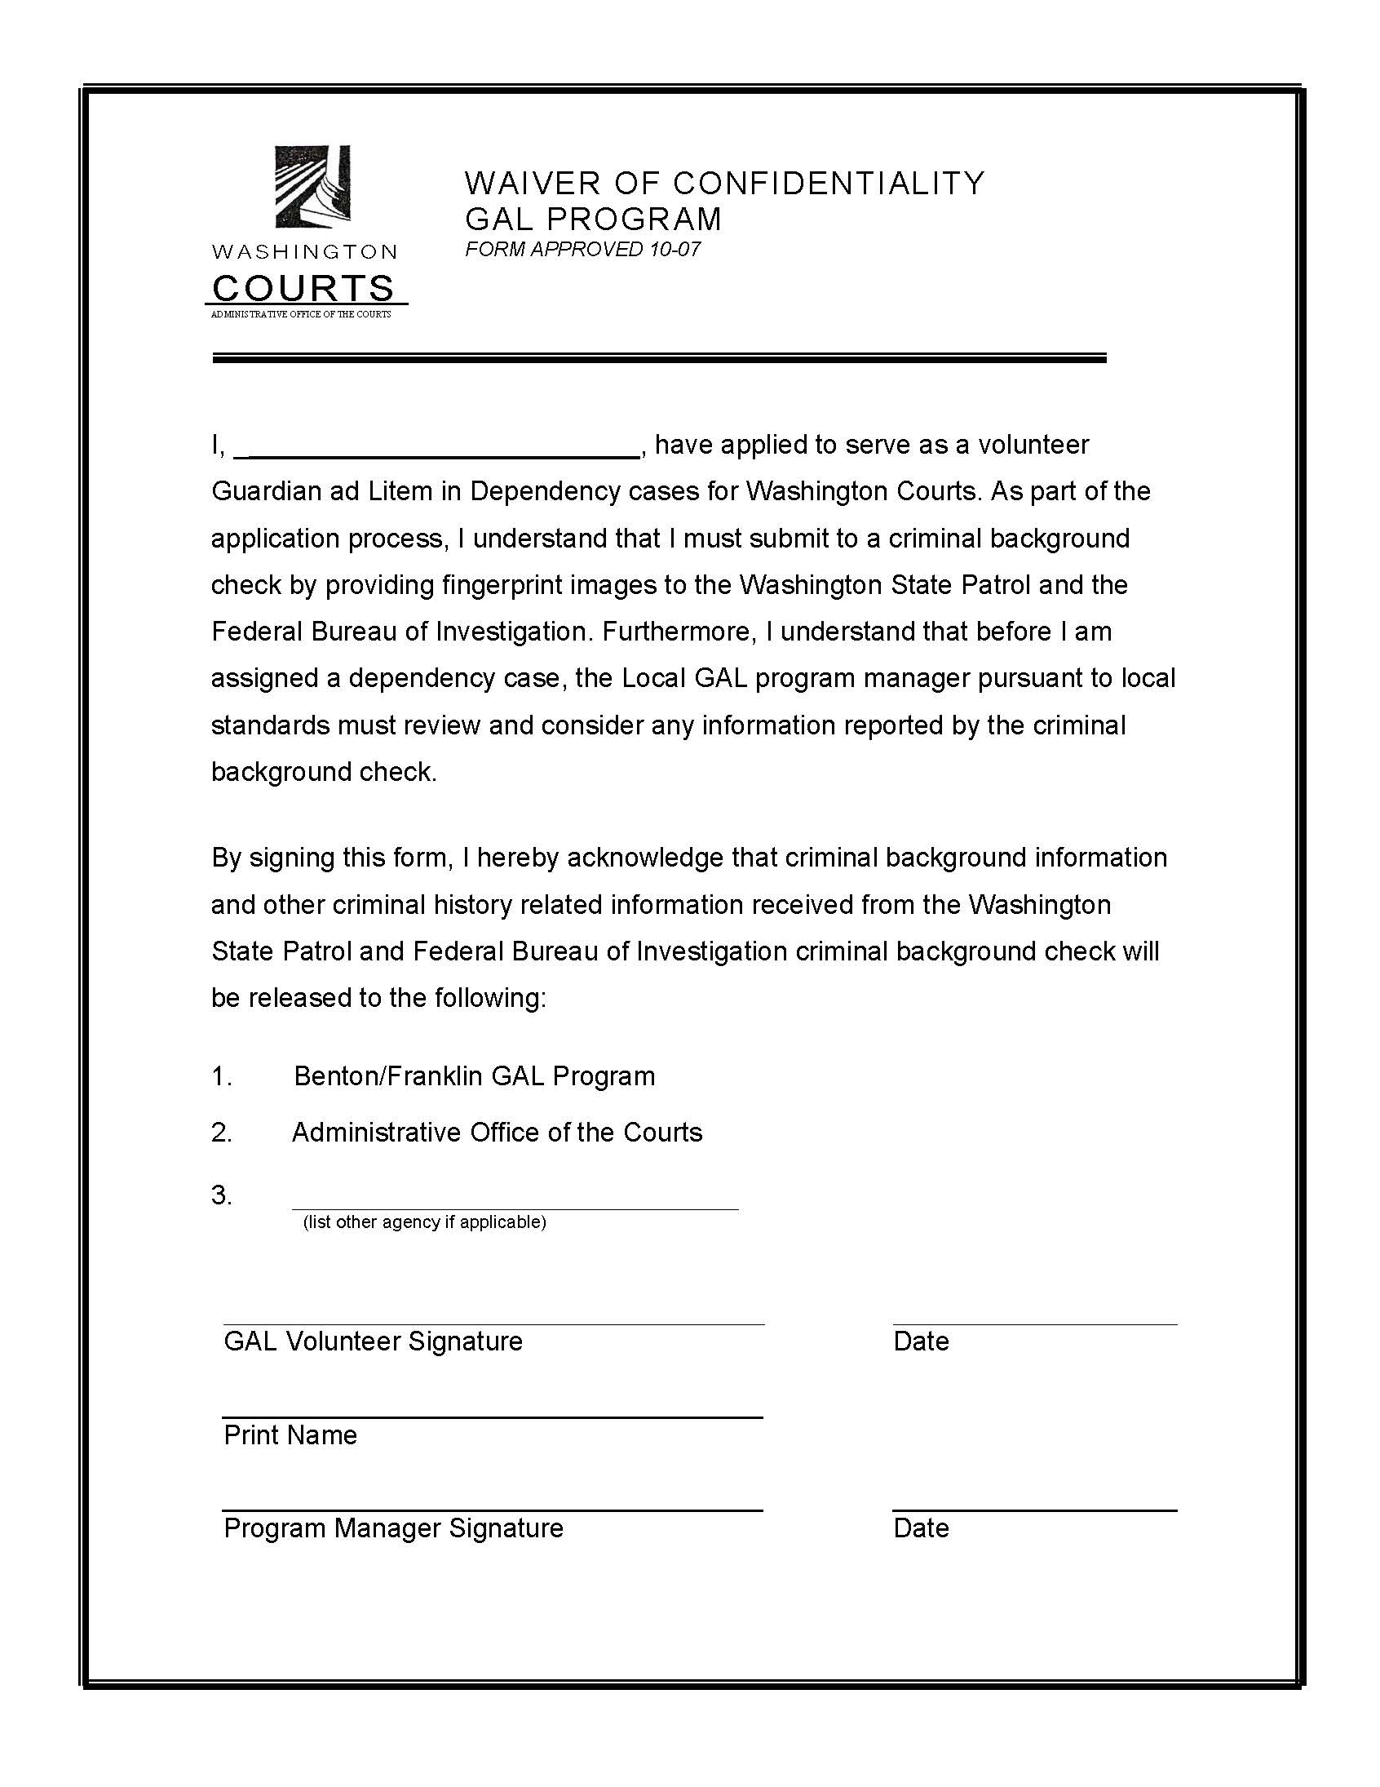
BENTON COUNTY GAL PROGRAM
VOLUNTEER PERSONAL INFORMATION SHEET
NAME: |  |  |  | RACE:  (for statistical purposes only; will not be included on Background Information Record)
HIGH SCHOOL: ________________________________________________
Graduated? Yes No
COLLEGE ATTENDED:
Name: | Dates attended: | Area(s) of study: | Graduated? |  | Degree Achieved (BA, BS, etc)
 |  |  | Yes No
 |  |  | Yes No
 |  |  | Yes No
GRADUATE SCHOOL ATTENDED:
Name: | Dates attended: | Area(s) of study: | Graduated? |  | Degree Achieved
 |  |  | Yes No
 |  |  | Yes No
 |  |  | Yes No
OTHER COUNTIES OR GAL PROGRAMS IN WHICH YOU WERE APPOINTED; DATE AND NUMBER OF APPOINTMENTS IN THAT COUNTY/PROGRAM:

OTHER TRAINING RELEVANT TO GAL ROLE: (Please List)

I understand that as a condition of appointment, a guardian ad litem’s background information record shall be made available to the court (per RCW 13.34.100). I agree to inform the Benton/Franklin GAL Program of any updates to the background information provided above.

____________________________________________________ ___________________________

Volunteer’s signature Date
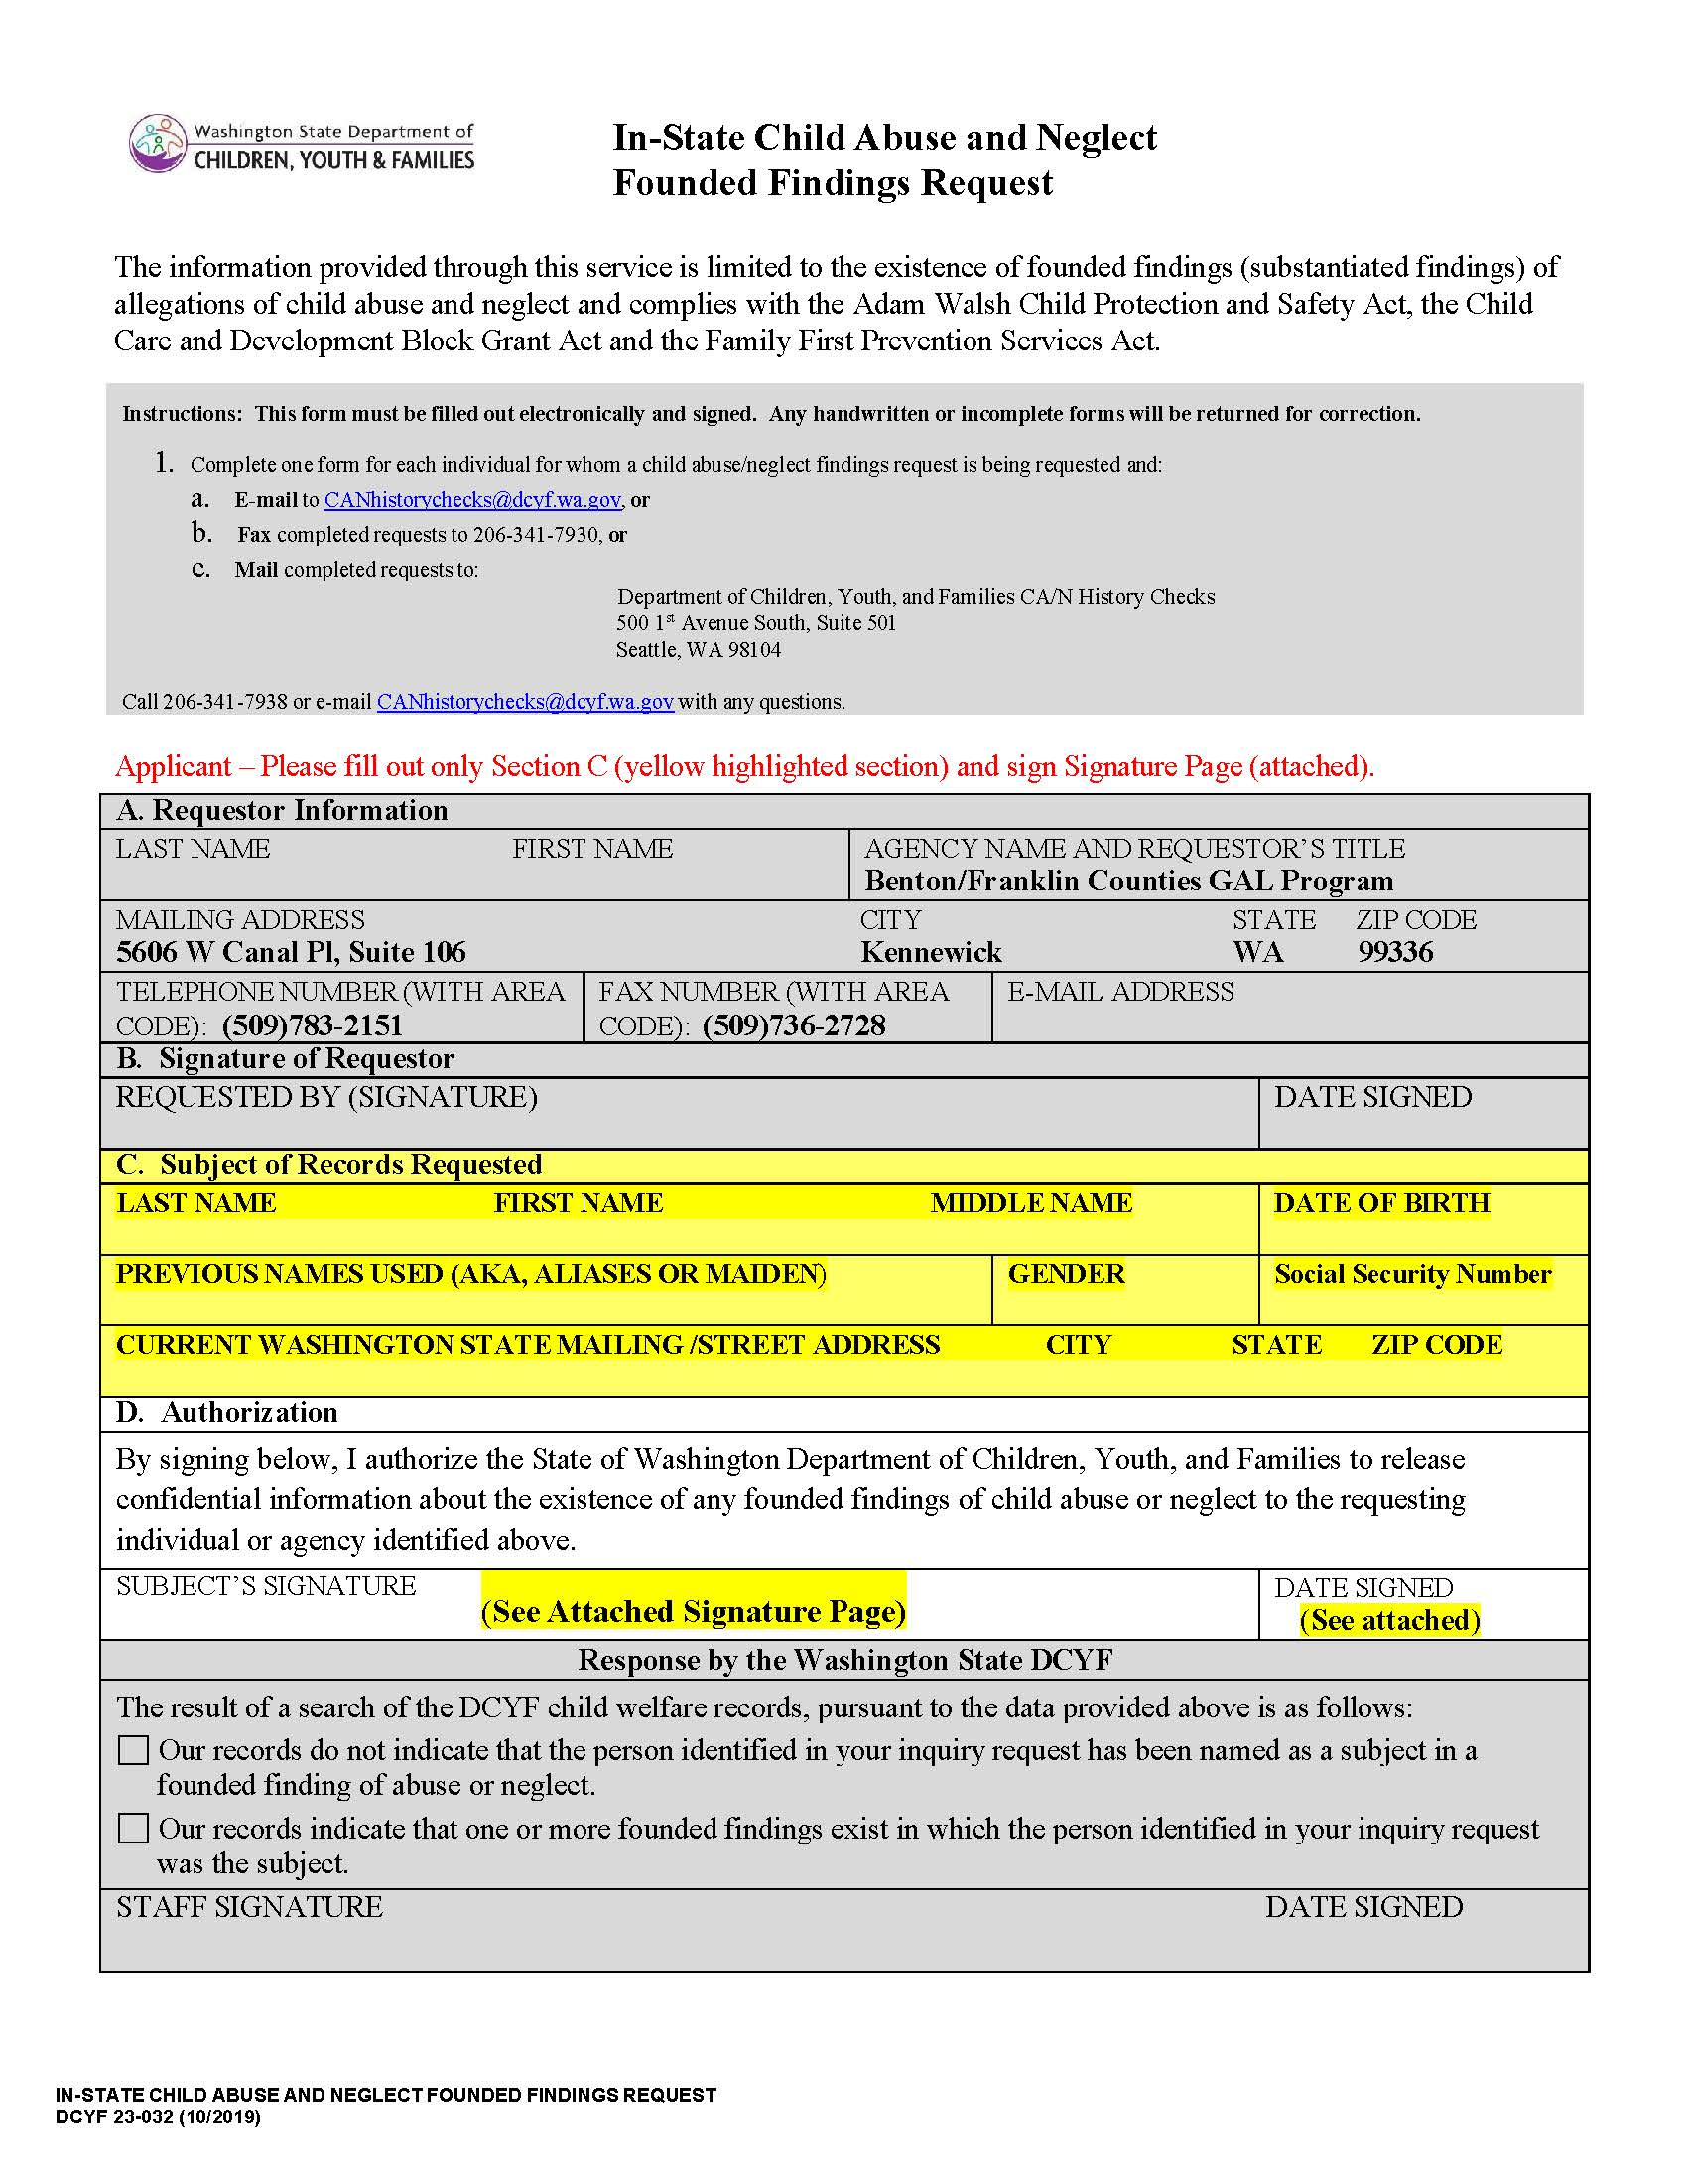
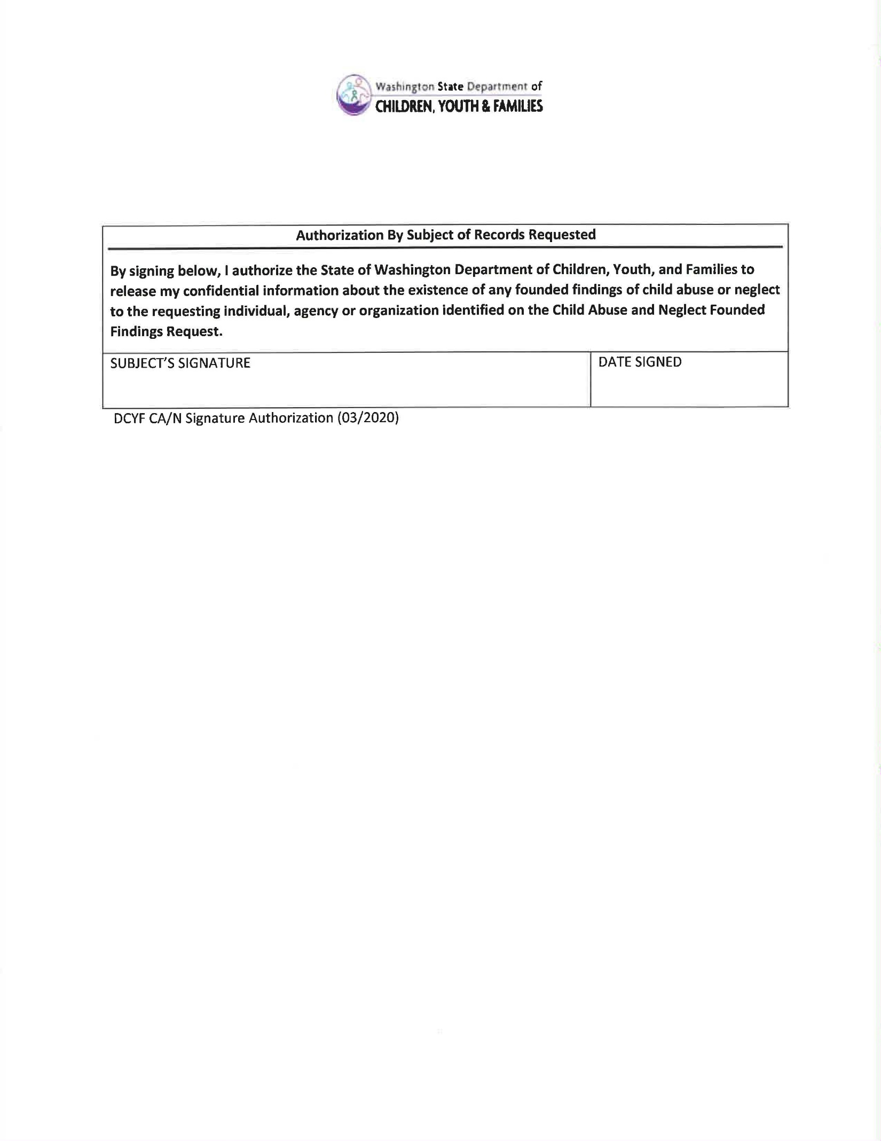
NONCRIMINAL JUSTICE APPLICANT’S PRIVACY RIGHTS

As an applicant who is the subject of a national fingerprint-based criminal history record check for a noncriminal justice purpose (such as an application for employment or a license, an immigration or naturalization matter, security clearance, or adoption), you have certain rights which are discussed below. All notices must be provided to you in writing. 1 These obligations are pursuant to the Privacy Act of 1974, Title 5, United States Code (U.S.C.) Section 552a, and Title 28 Code of Federal Regulations (CFR), 50.12, among other authorities.
- You must be provided an adequate written FBI Privacy Act Statement (dated 2013 or later) when you submit your fingerprints and associated personal information. This Privacy Act Statement must explain the authority for collecting your fingerprints and associated information and whether your fingerprints and associated information will be searched, shared, or retained. 2
- You must be advised in writing of the procedures for obtaining a change, correction, or update of your FBI criminal history record as set forth at 28 CFR 16.34.
- You must be provided the opportunity to complete or challenge the accuracy of the information in your FBI criminal history record (if you have such a record).
- If you have a criminal history record, you should be afforded a reasonable amount of time to correct or complete the record (or decline to do so) before the officials deny you the employment, license, or other benefit based on information in the FBI criminal history record.
- If agency policy permits, the officials may provide you with a copy of your FBI criminal history record for review and possible challenge. If agency policy does not permit it to provide you a copy of the record, you may obtain a copy of the record by submitting fingerprints and a fee to the FBI. Information regarding this process may be obtained at https://www.fbi.gov/services/cjis/identity-history-summary-checks and https://www.edo.cjis.gov.
- If you decide to challenge the accuracy or completeness of your FBI criminal history record, you should send your challenge to the agency that contributed the questioned information to the FBI. Alternatively, you may send your challenge directly to the FBI by submitting a request via https://www.edo.cjis.gov. The FBI will then forward your challenge to the agency that contributed the questioned information and request the agency to verify or correct the challenged entry. Upon receipt of an official communication from that agency, the FBI will make any necessary changes/corrections to your record in accordance with the information supplied by that agency. (See 28 CFR 16.30 through 16.34.)
- You have the right to expect that officials receiving the results of the criminal history record check will use it only for authorized purposes and will not retain or disseminate it in violation of federal statute, regulation or executive order, or rule, procedure or standard established by the National Crime Prevention and Privacy Compact Council.3

__________________________________
1 Written notification includes electronic notification but excludes oral notification.
2 https://www.fbi.gov/services/cjis/compact-council/privacy-act-statement
3 See 5 U.S.C. 552a(b); 28 U.S.C. 534(b); 34 U.S.C. § 40316 (formerly cited as 42 U.S.C. § 14616), Article IV(c); 28 CFR 20.21(c), 20.33(d) and 906.2(d)

Applicant Initials | Date copy provided

Updated 11/6/2019

